**Data Science Project**

### **Recommender System**

If you have tried online shopping, you must have noticed that when you are checking out a product on an eCommerce site, there is a list of suggested products that you are presented with. In this project, you will work on different types of recommendation systems

**For this, we are attaching a dataset containing information about recommendation system for online retail data, so that we can understand what type of product can be recommended.**

We are providing a **dataset** from Kaggle, which contains historical information about online retail data which can be used to detect which product is highly recommended. Below are all the columns from the dataset I’m using here

Invoice Number: This is the number that identifies a transaction.

Stock Code: This refers to the product ID.

Description: This describes the product that a user purchased.

Quantity: It specified the quantity of the item purchased.

Invoice Date: The date on which the transaction took place.

Unit Price: Price of one product.

Customer ID: It identifies the customer.

Country: The country where the transaction was performed.

**Language Used:** Python

Dataset is attached below in email as csv format …..Now start working on data Science/python to find recommendation system using python

Architecture:

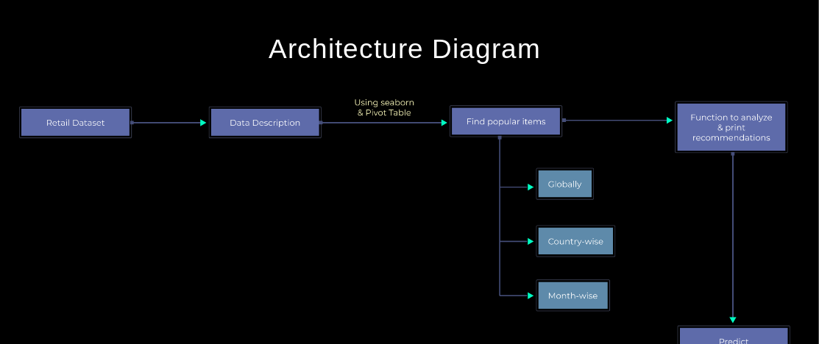

**Note: Complete the task and share the code to** [**support@intrainz.com**](mailto:support@intrainz.com) **so u can receive the certification**

**All the best!**